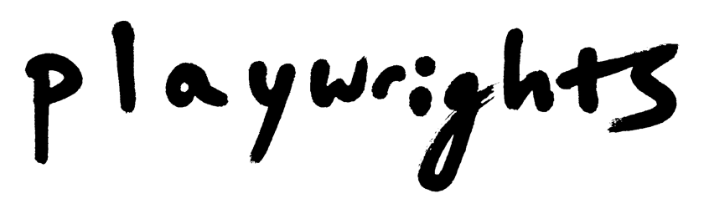
Heroes of the Fourth Turning
Press Campaign Snapshot

Targets

For almost all of my clients, I pursue print, online, radio, and television media—coverage by journalists, critics, and on-air personalities, not paid advertising (which falls to the marketing department, rather than to the press representative).

For any theater production, my targets include editors, reporters, critics, and broadcast producers in these forms of media, including The New York Times, New York Magazine / Vulture, The New Yorker, amNY / Metro, The New York Observer, Vanity Fair, Vogue, Entertainment Weekly, American Theatre Magazine, Playbill, Theatermania, Broadway.com, New York Stage Review, Backstage, Variety, The Wrap, Slate, The Daily Beast, Gothamist, NPR, WNYC Radio’s arts and culture show “All of It,” NY1’s theater show “On Stage,” WNET’s (PBS) weekly culture show “NYC-Arts,” and more.

For Heroes of the Fourth Turning, given the subject matter and Will’s biography, political media were central to the press campaign. The target list, therefore, also including WNYC’s politics and news program “The Brian Lehrer Show,” Rod Dreher at The American Conservative, the radio show Democracy Now, The New York Times podcast “The Argument,” co-hosted by Ross Douthat and Michelle Goldberg, the New York Times columnist David Brooks, the New York Magazine writer Frank Rich, Vox, The Catholic Herald, and more.

Campaign Timeline

Conversation with Will Arbery (Playwright) and Danya Taymor (Director) (July 2019)
First Press Release, announcing cast (August 8, 2019)
Meet and Greet – Photos (August 16, 2019)
Previews Beginning Press Release (September 9, 2019)
B-Roll Filming (September 18, 2019)
Press Performances (October 2-6, 2019)
Opening Night (October 7, 2019)
Extension Press Release (to November 10) (October 11, 2019)
Additional Extension Press Release (to November 17) (October 23, 2019)

